Behind the leaves

Step by step



1. Choose three different coloured felt pens and then draw large circular shapes onto your sheet of paper.

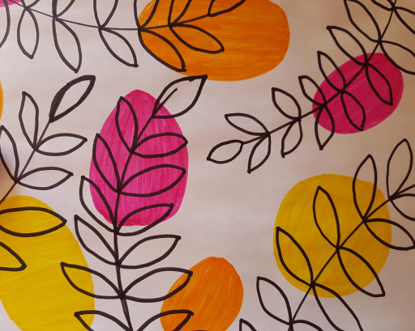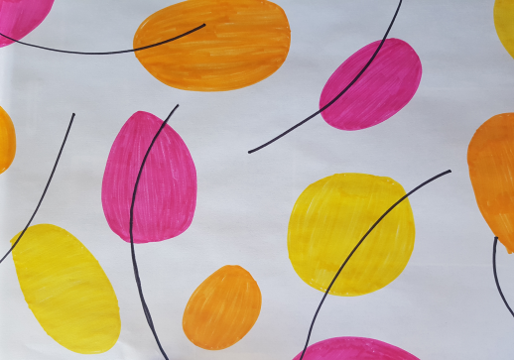

5. Draw tiny circles in each leaf and then colour the leaves in black, leaving the interior of the circles white.

4. Using the same fine black felt pen, draw in the leaves along the stems. They are tiny leaves.

2. Colour in the shapes with the same coloured felt pen used for the outline.

3. Using a fine black felt pen, draw semi-circles which will become the stems for your leaves.

