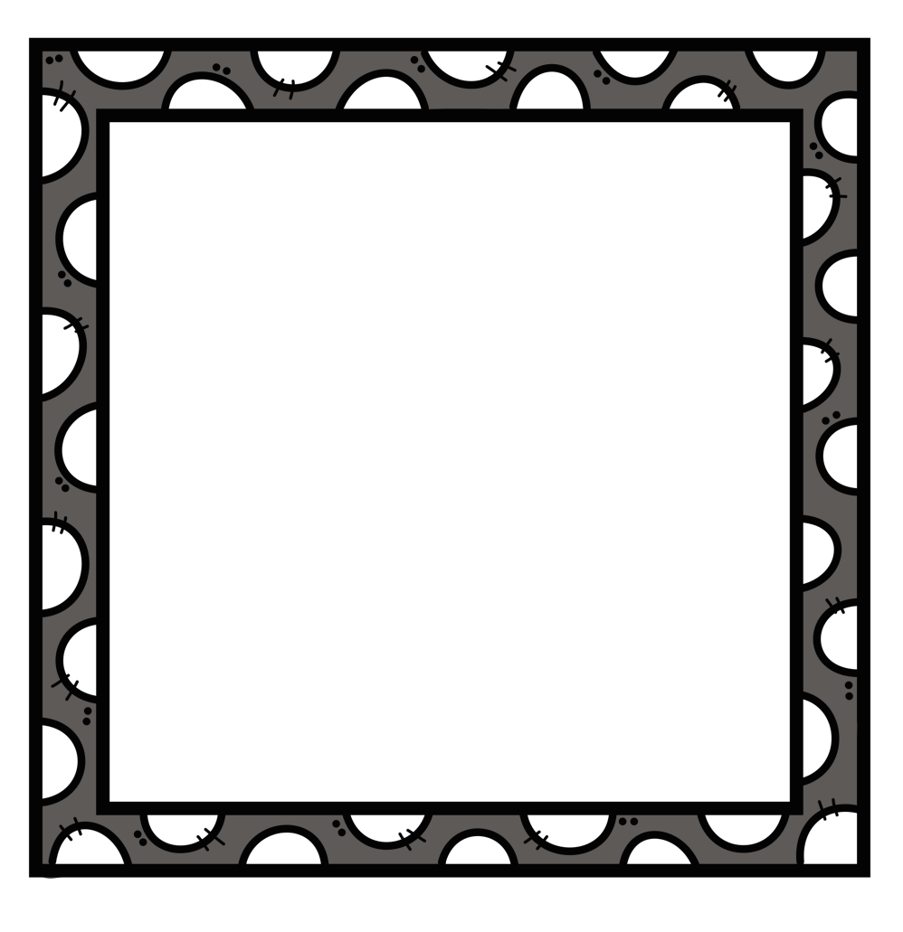
x 5 =
32 = x
x 3 =
x 5 = 3

0 | 1 | 2 | 3 | 4
5 | 6 | 7 | 8 | 9
x = 2
14 = x
x 6 =
x 4 = 3

0 | 1 | 2 | 3 | 4
5 | 6 | 7 | 8 | 9
x = 32

= 5 x
3 x =
x 5 = 3

0 | 1 | 2 | 3 | 4
5 | 6 | 7 | 8 | 9
x 5 =
2 = 3 x 8
x = 6
x 7 =

0 | 1 | 2 | 3 | 4
5 | 6 | 7 | 8 | 9

3 x 5 = 15
32 = 4 x 8
9 x 3 = 27
6 x 5 = 30
5 x 4 = 20
14 = 2 x 7
3 x 6 = 18
9 x 4 = 36
8 x 4 = 32
27 = 3 x 9
3 x 5 = 15
6 x 5 = 30
2 x 5 = 10
24 = 3 x 8
7 x 8 = 56
9 x 7 = 63

