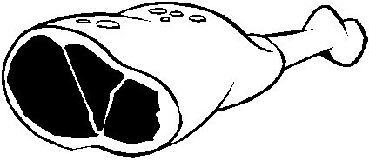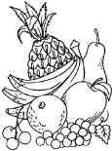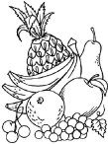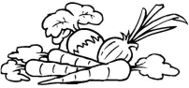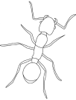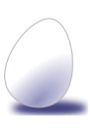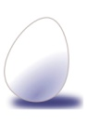

|  |  |  |  |  |  |  |  |
| --- | --- | --- | --- | --- | --- | --- | --- |
| G:\ecole\banque  images\Monochro\Requin.bmp | G:\ecole\banque  images\Monochro\Lapin.bmp | G:\ecole\banque  images\Monochro\Cochon.bmp | G:\ecole\banque  images\Monochro\Lion.bmp | G:\ecole\banque  images\Monochro\Homme.bmp | G:\ecole\banque  images\Monochro\Escargot.bmp | G:\ecole\banque  images\Monochro\Poule.bmp | G:\ecole\banque  images\Monochro\Ours.bmp |
| G:\ecole\banque  images\Monochro\Chevre.bmp | G:\ecole\banque  images\Monochro\Cheval.bmp | G:\ecole\banque  images\Monochro\Araignee.bmp | G:\ecole\banque  images\Monochro\Crocodil.bmp | G:\ecole\banque  images\Monochro\Dauphin.bmp | G:\ecole\banque  images\Monochro\Vache.bmp | G:\ecole\banque  images\Monochro\Elephant.bmp | G:\ecole\banque  images\Monochro\Chenille.bmp |